

*OPERATING SYSTEM*

*Lab Manual*

*[Summer 2019]*

|  |  |
| --- | --- |
| *Student Name: Babar Subhani* |  |
| *Student Id: 15031* |  |
| |  |  | | --- | --- | | *Prepared By: Dr. Noman Islam* |  | | *Instructor: Dr. Noman Islam* |  | |  |

**LIST OF EXPERIMENTS**

|  |  |  |  |
| --- | --- | --- | --- |
| **S. No** | **Date** | **Experiment** |  |
| **1** | __/__/__ | To study and implement socket programming in Java |  |
| **2** | __/__/__ | To study and implement file I/O in Java |  |
| **3** | __/__/__ | To study and implement multi-threading in Java |  |
| **4** | __/__/__ | To study and execute basic Linux commands on a terminal |  |
| **5** | __/__/__ | To study and execute system administration commands on a terminal |  |
| **6** | __/__/__ | To study and implement shell programming in Linux |  |
| **7** | __/__/__ | To study and implement information security techniques in Linux |  |
| **8** | __/__/__ | To study and implement concurrency control techniques in Java |  |
| **9** | __/__/__ | To study and implement process scheduling algorithms in Java |  |
| **10** | __/__/__ | To study and implement containers and dockers |  |
| **11** | __/__/__ | To study and implement page replacement algorithms in Java |  |
| **12** | __/__/__ | To study and implement disk scheduling algorithm in Java |  |

**To study and implement File I/O in Java**

**Instructions:**

Type the following program and save.

//FileTest.java

import java.io.*;

class FileTest

{

public void fileWrite()

{

File dstFile = new File("K:\\myOutput\\outputfile.txt");

PrintWriter out = new PrintWriter

(new BufferedWriter(new FileWriter(dstFile)));

out.print("Hello ");

out.println("world");

out.close();

}

}

//FileTestMain.java

import java.io.*;

class FileTestMain

{

public static void main(String[] args)

{

FileTest fileTest = new FileTest();

fileTest.fileWrite();

}

}

**Lab Tasks**

1. Try to compile the class FileTest. What goes wrong? This is because opening up a file could throw an IOException, which is a checked exception. This means you have to tell Java how to deal with it, or the program won't compile

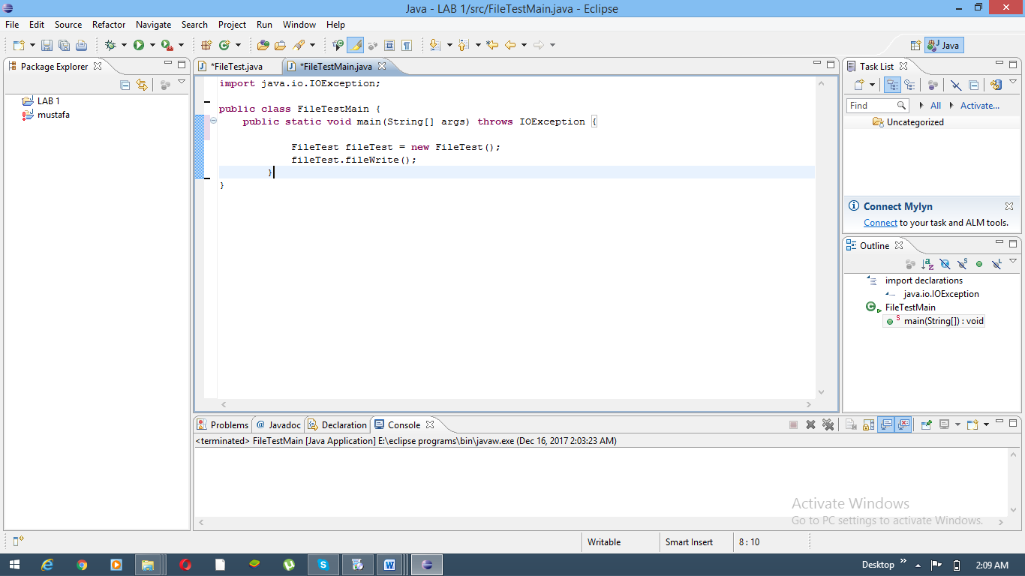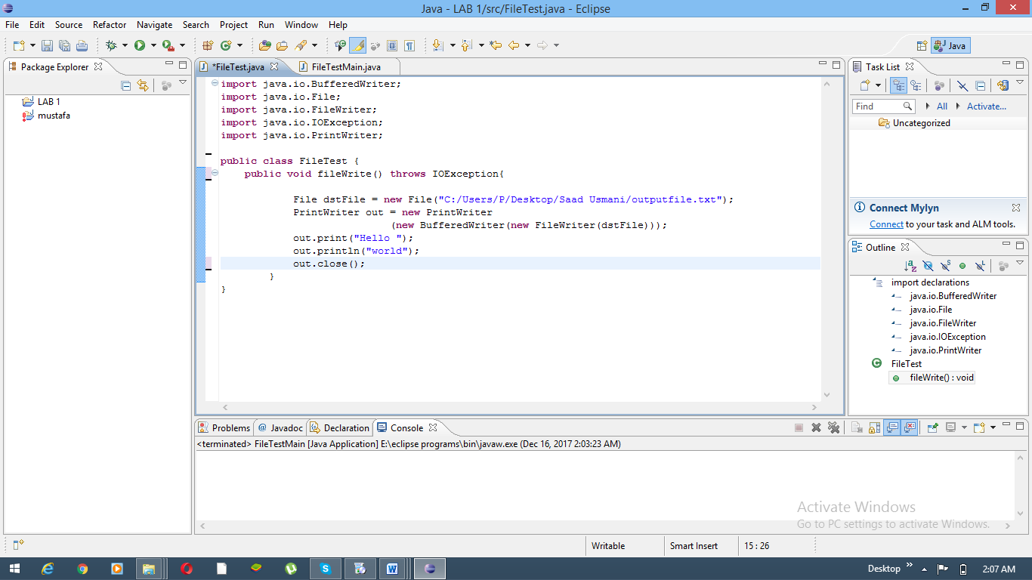

1. Run your program again. If all went successfully, open up "My Computer", and find your FilePractice folder on your K drive. You should be able to find the file "outputfile.txt". Double click on it, and take a look. What do you see?

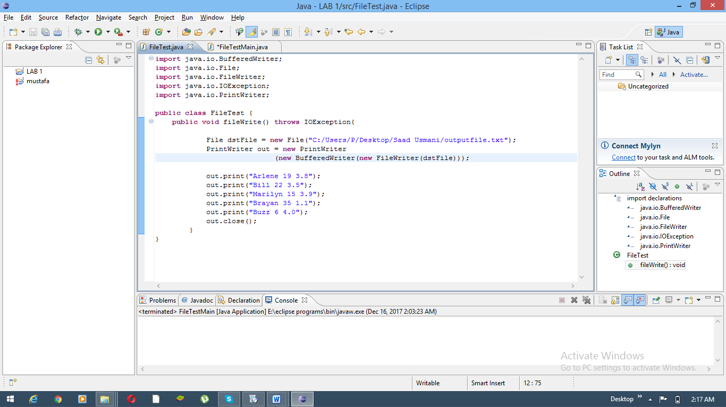

1. Add the following method to your FileTest class:

public void consoleRead() throws IOException

{

BufferedReader in = new BufferedReader(new InputStreamReader(System.in));

System.out.print("What is your first name? ");

String first = in.readLine();

System.out.print("What is your last name? ");

String last = in.readLine();

System.out.println("Your name is " + last + ", " + first + ".");

}

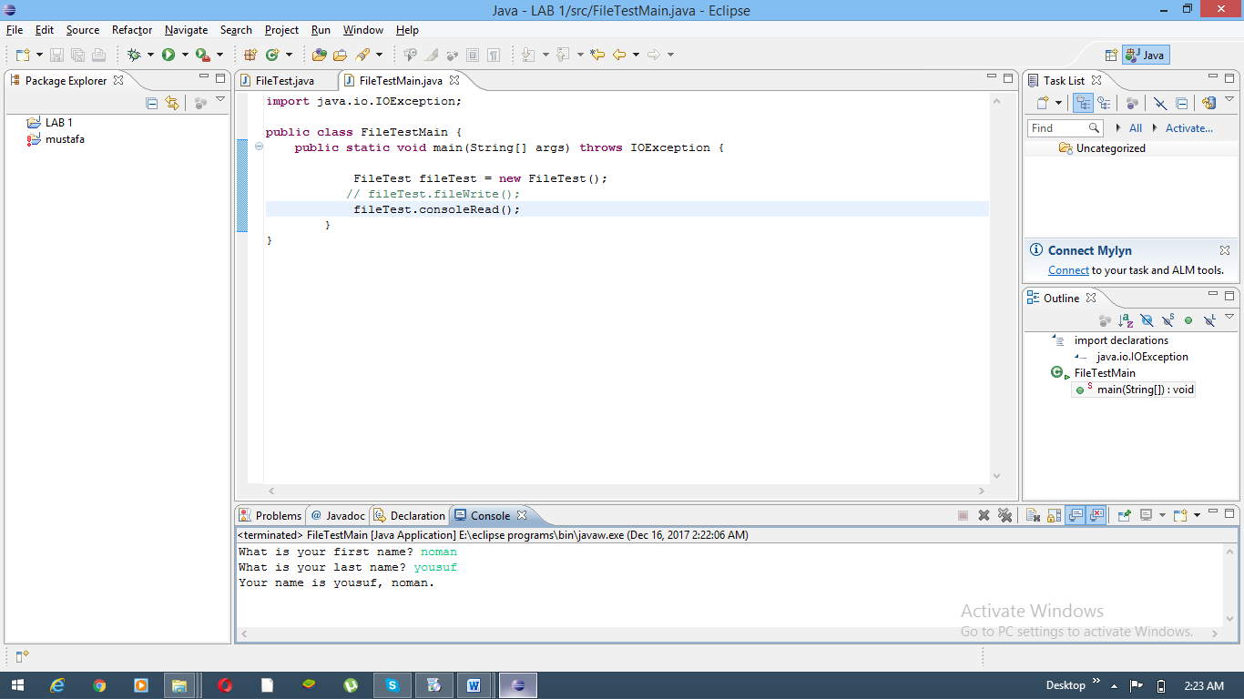

1. Add the following method to FileTest.

public void fileRead() throws IOException

{

File srcFile = new File("K:\\FilePractice\\outputfile.txt");

BufferedReader in = new BufferedReader(new FileReader(srcFile));

String text = in.readLine();

System.out.println(text);

in.close();

}

Run the method. What do you see? Modify this method to print out the names, ages, and gpas of the five people you stored back in Task 1.

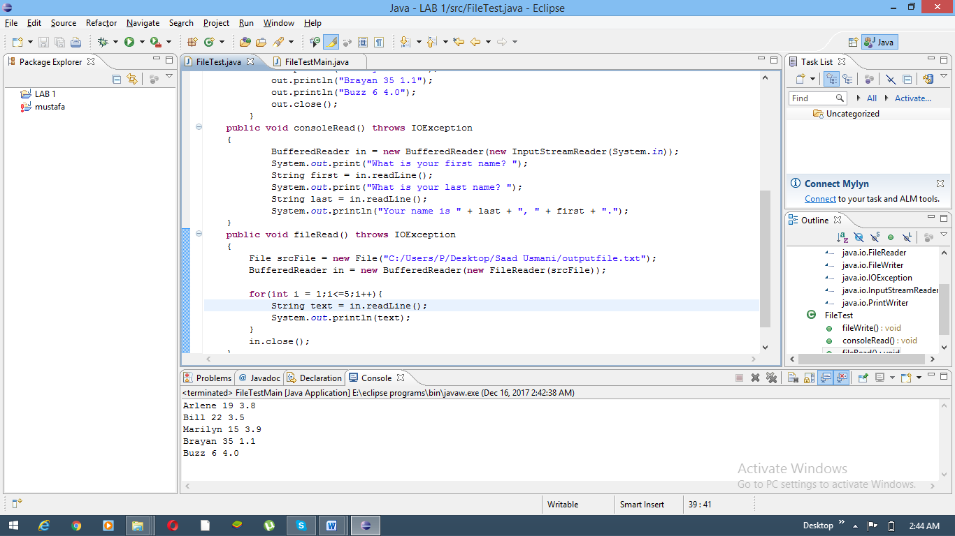

**Lab 2**

**To study and implement socket programming in Java**

Sockets provide the communication mechanism between two computers using Transmission Control Protocol (TCP) or User Datagram Protocol (UDP). This lab will demonstrate how to implement TCP sockets using Java. Before starting the lab, download and install Java and Eclipse IDE by following the instructions below:

1. Download and Install Java Development Kit (JDK)’s latest version
2. Download ‘Eclipse’ on your computer
3. Go to Eclipse folder and Run eclipse.exe file
4. The Eclipse environment will start. Now perform the lab tasks.

**Lab Tasks:**

1. 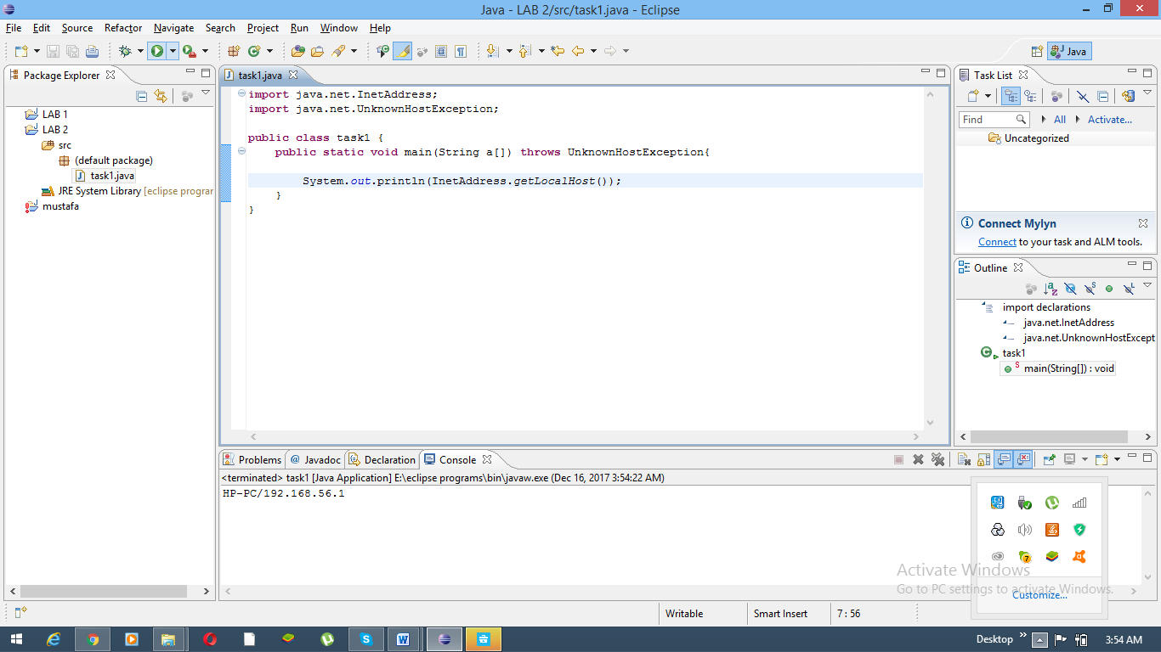Find the IP address of a local host using java program. Use the InetAddress class.



1. Write a small port scanner application. The program usage is as follows:

E:\ >java PortScanner 132 137

Port not in use : 132

Port not in use : 133

Port not in use : 134

Port in use : 135

Port not in use : 136

Port not in use : 137

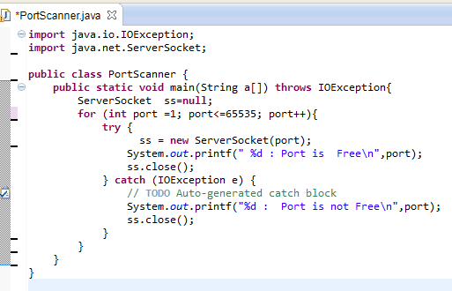

1. Write a small server that accepts socket connection on port 2020. Develop a client application that connects to the server.
   1. Using BufferedOutputStream, write to the server “Hello”
   2. The server should respond with the word Hello

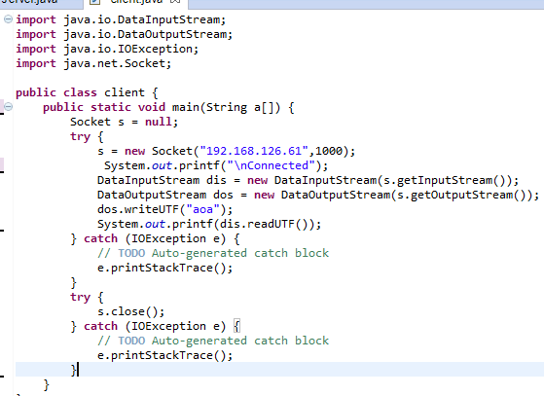

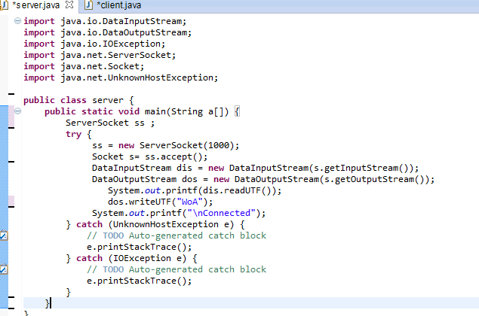

**To study and implement multi-threading in Java**

**Instructions:**

1. A thread is an independent unit of execution.
2. In Java, the Runnable interface and Thread class of package java.lang are used for implementation of thread
3. To implement a thread, the desired class must implement the Runnable interface and provide the run() method.

public class MyThread implements Runnable {

public void run() {

//implementation of thread  
 }

}

1. The Thread class can then be used to start a thread as follows:

public class TestThread

{

public static void main( String[] args )

{

MyThread m = new MyThread();

Thread t = new Thread(m);

m.start();

}

}

**Lab Tasks:**

1. Write a class that implements Runnable. Define a constructor that takes the name of the thread as argument. The thread upon execution will print the name of the thread in a while loop. Define and run 5 thread objects. What output do you see?
2. In task 1, modify the run method to randomly sleep the thread for few milliseconds. Observe the output.

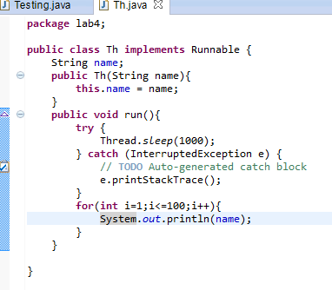

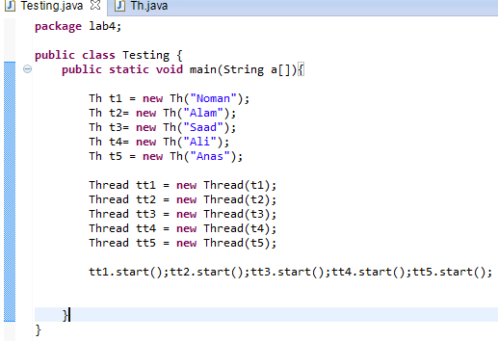

**To study and execute basic Linux commands on a terminal**

Linux is a Unix-like and mostly POSIX-compliant computer operating system (OS) assembled under the model of free and open-source software development and distribution. In this lab, we will work on Ubuntu, one of the flavors of Linux. For this purpose, we will use virtualization environment.

**Lab Tasks:**

1. Using ls command find out the contents of current directory
2. What are the permissions for normal user, group and world for each file
3. Find out the name of current working directory
4. Create a new folder named “lab os” using the mkdir command
5. Switch to the directory “lab os”
6. Create a file in the directory named “lab4.txt” using touch command
7. List down the contents of file using cat command. Try using “more” and “less” option
8. Find out the space consumed by directory using “du” command
9. Copy the file to parent directory using cp command
10. Remove the file using rm command
11. Remove the directory using rmdir command
12. Check the free space on disk using df command
13. Change the password of the user using passwd command
14. Switch to super user, using the command “su”
15. Using the history command, list down the commands run on the terminal window

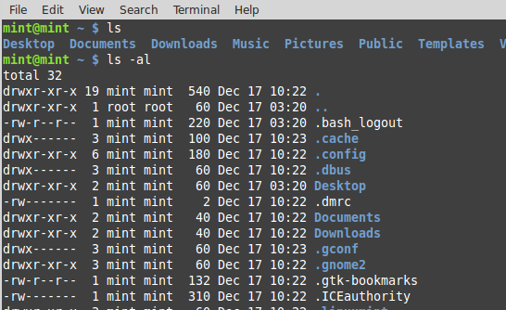

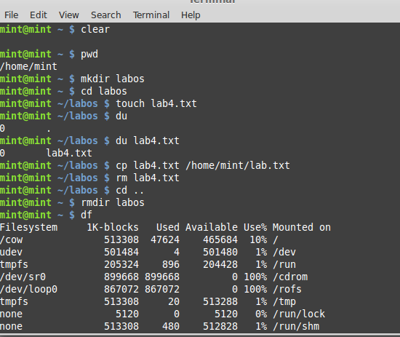

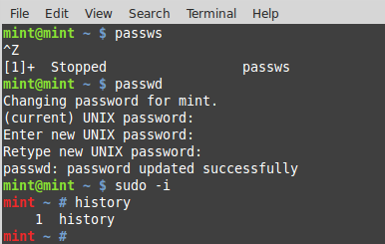

**To study and execute system administration commands on a terminal**

**Instructions:**

Linux comprises a set of commands for basic system administration. In this lab, we will study these commands.

**Lab Tasks:**

1. Using the ‘uptime' command, since how long your system is running and the number of users that are currently logged in.
2. Using the ‘w’, display the users currently logged in and their process along-with load averages
3. Using the ‘users’ command, display the currently logged in users.
4. Using the ‘top’ command, display processor activity of your system and also displays tasks managed by kernel in real-time.
5. Using ‘tar’ command, compress your home directory in Linux.
6. ‘lsof’ command to list all open files
7. Using the ‘last’ command, watch activity of ‘mint’ user in the system
8. Using the ‘env’ command, lists all the environment variables of your system. Use ‘echo’ command to print values of $HOME and $PATH
9. The ‘ps’ command displays about processes running in the system. Try option –ax, -u.
10. The ‘kill’ command can be used to terminate process. Using this command terminate some processes of your system
11. ‘ifconfig’ command is used to show the configuration of internet on LINUX. Use this command to find IP and MAC address of your computer
12. Using the ‘netstat’ command, show the status of your network
13. Using the ping command, to ping your localhost
14. Create a group named ‘student’ using groupadd
15. Create a file named ‘hello.txt’
16. Using the ‘useradd’ command create a user with your name in the group student
17. Change the owner of hello.txt to user you just created
18. Change the group owner of hello.txt to group student

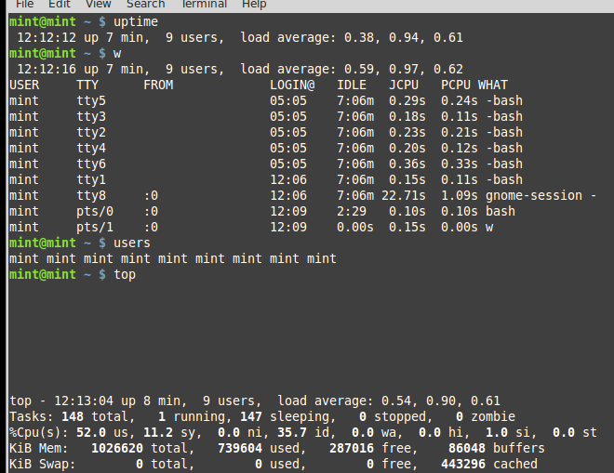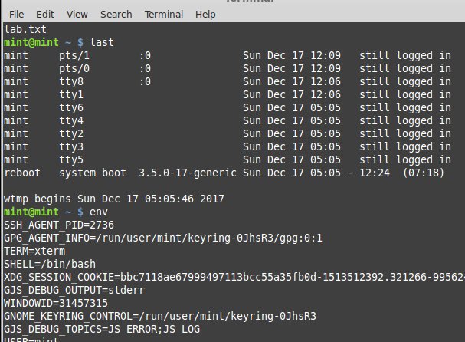

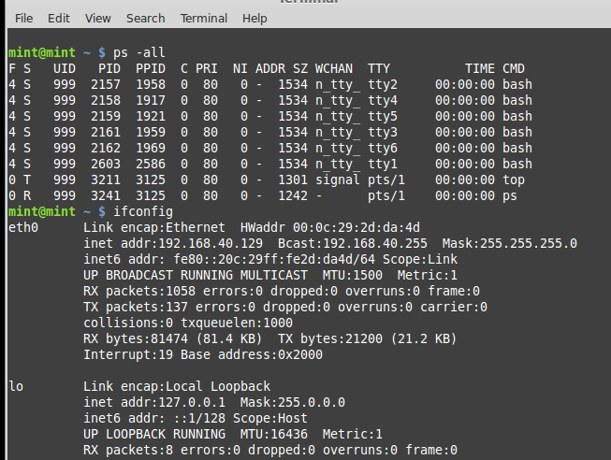

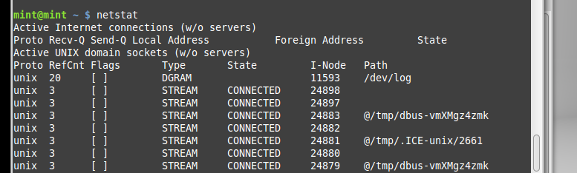

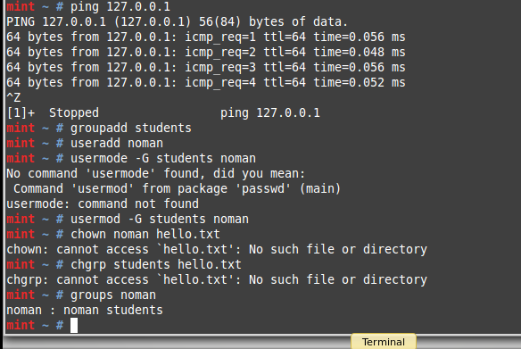

**To study and implement shell programming in Linux**

**Instructions:**

1. A shell script is a computer program designed to be run by the Unix shell, a command-line interpreter
2. The various dialects of shell scripts are considered to be scripting languages.
3. Typical operations performed by shell scripts include file manipulation, program execution, and printing text.

**Lab Tasks:**

1. Write a script that backs itself up, that is, copies itself to a file named backup.sh.   
   Hint: Use the cat command
2. Write a script that echoes itself to stdout, but backwards.

Hint: Use the tac command

1. Perform a recursive directory listing on the user's home directory and save the information to a file.
2. Write a script that reads each line of a target file, then writes the line back to stdout, but with an extra blank line following. This has the effect of double-spacing the file.
3. Write a shell script that takes a command –line argument and reports on whether it is directory, a file
4. Write a shell script program to display list of user currently logged in.
5. Shell script program to count number of files in a Directory.

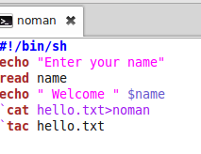

**To study and implement information security techniques in Linux**

In this lab, we will explore the basic information security tools available in Linux. There are a number of tools available in Linux. This lab only covers nmap, whois and wireshark tool

**Lab Tasks**

* **Download and install the three tools nmap, whois and wireshark tool on Linux. What command did you use to install?**

Sudo apt-get install nmap

Sudo apt-get install whois

Sudo apt-get install wireshark

* **Now run the nmap tool on** [**http://iqra.edu.pk**](http://iqra.edu.pk/)**. Capture the output**.

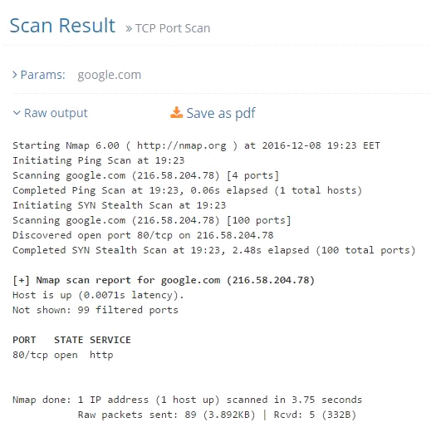

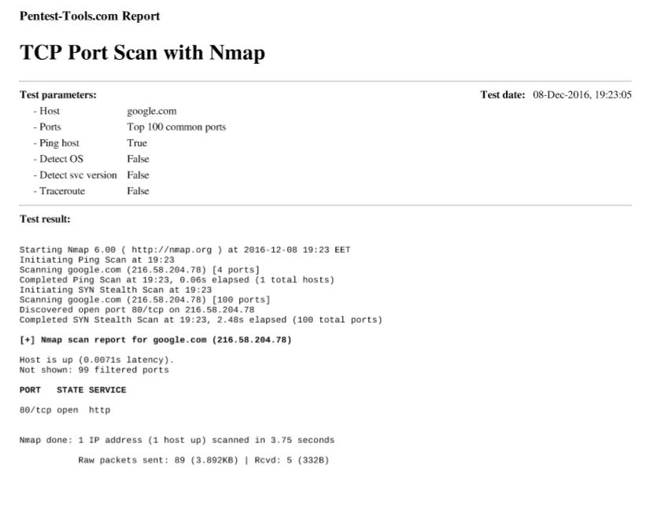

* **Provide a commentary on the output**

This output is showing the route of the address [www.google.com](http://www.google.com/) in which all the ports, ip addresses of the routers and host can be seen easily.

* **Run the whois tool on** [**http://iqra.edu.pk**](http://iqra.edu.pk/)**. Capture the output**

**Run the whois tool on** [**http://iqra.edu.pk**](http://iqra.edu.pk/)**. Capture the output.**

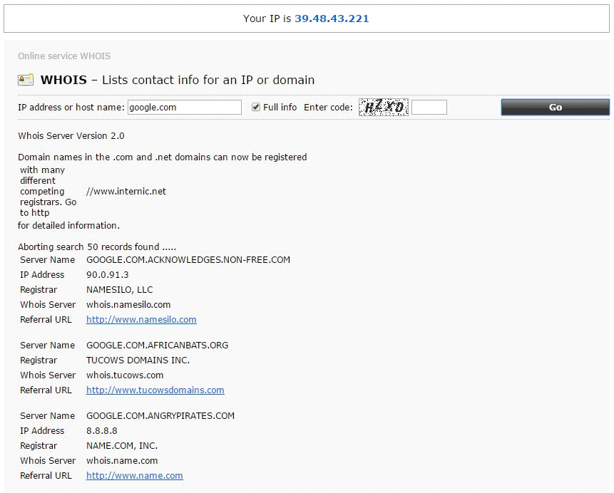

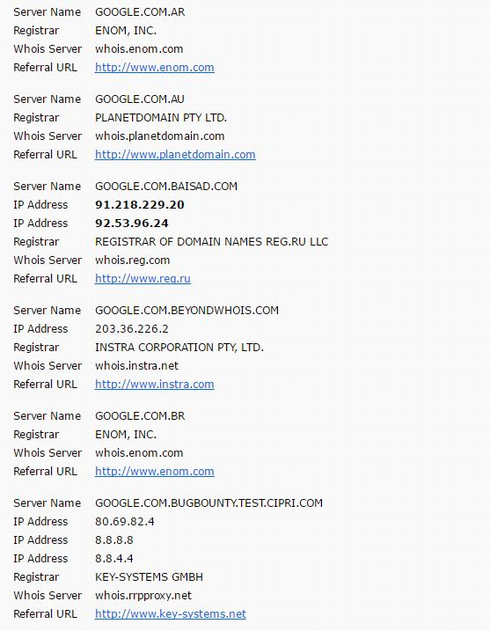 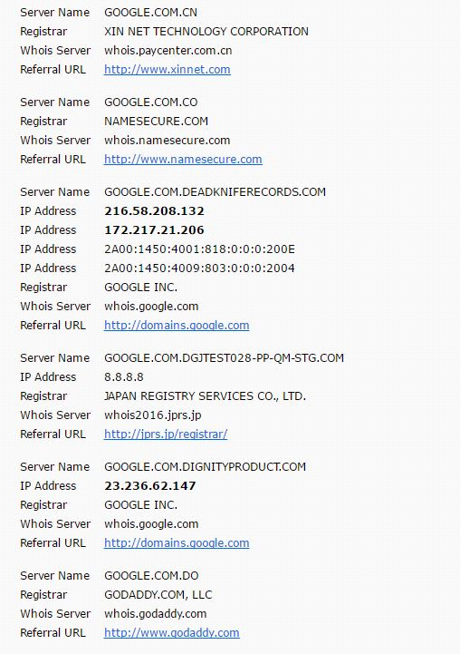 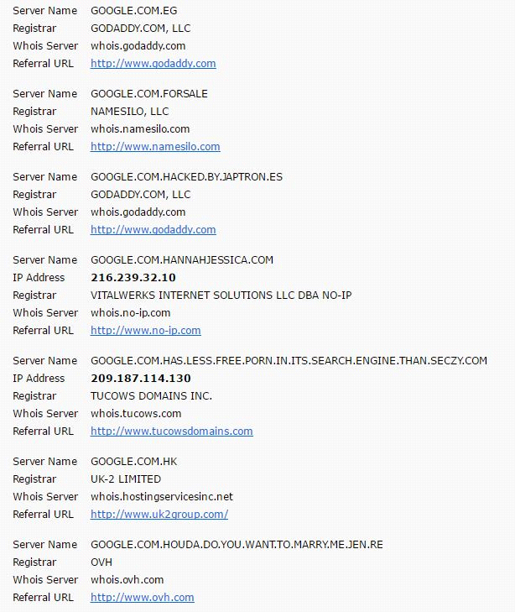 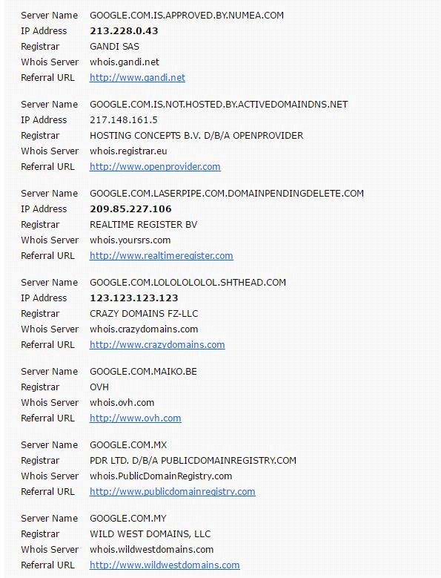 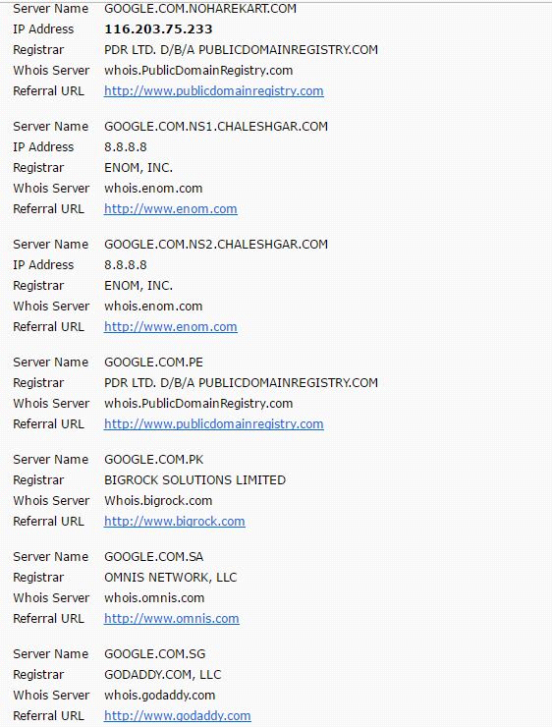 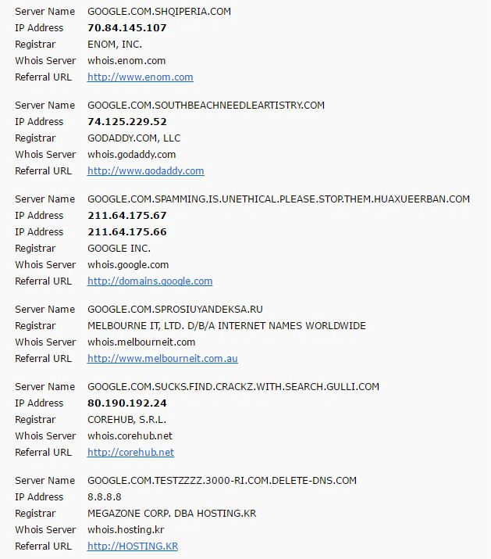 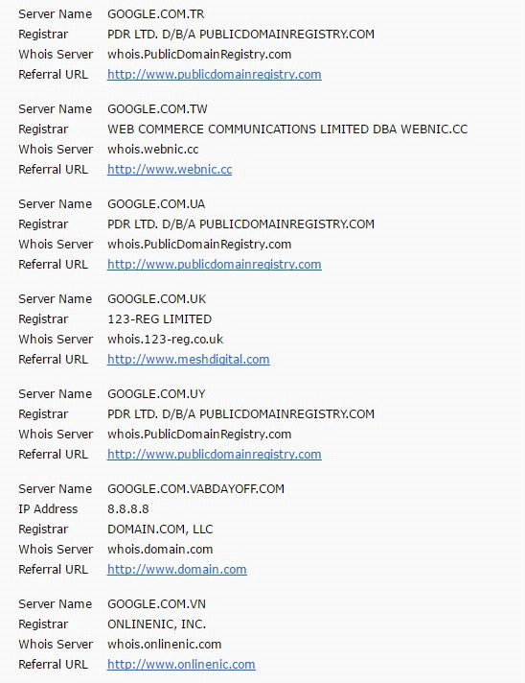 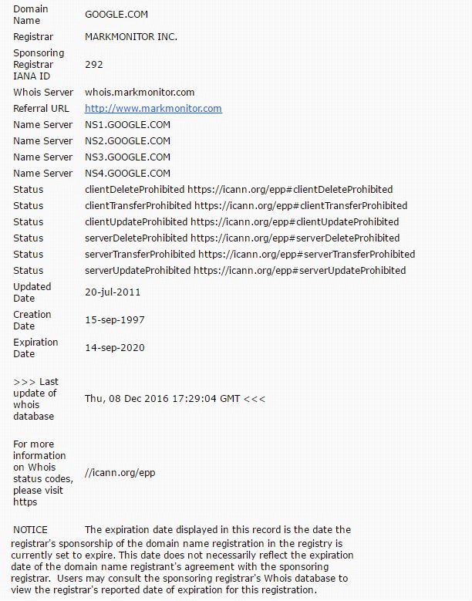

* **Provide a commentary on the output**

**These are the outputs of the WHOIS command which is use to allocate the resources from which a particular address is reaching to us.**

* **With the wireshark tool capturing the interface data, browse** [**http://iqra**](http://iqra/) **.edu.pk**

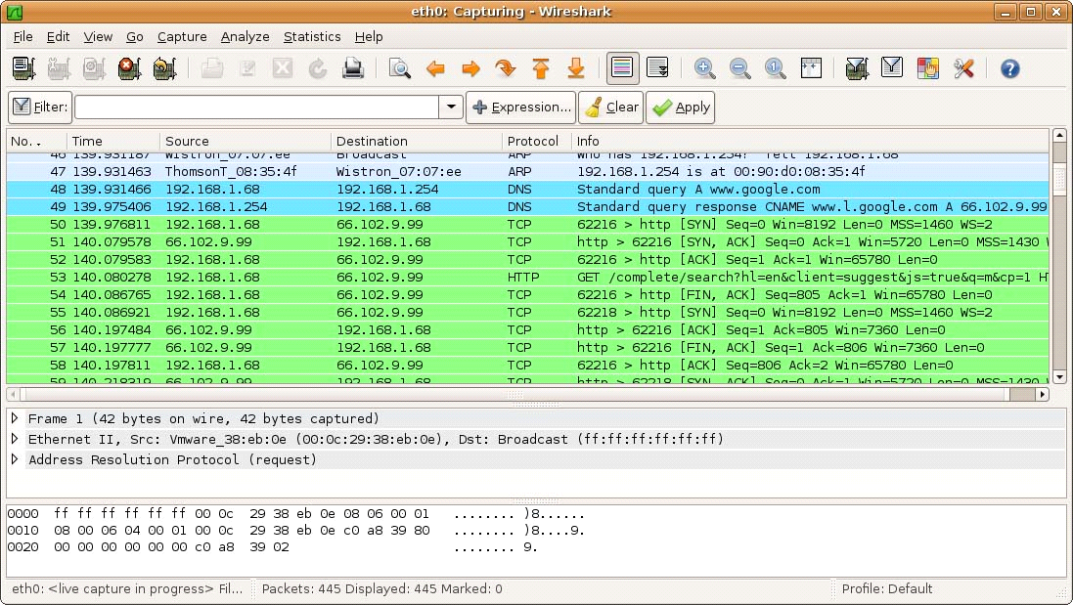

**To study and implement concurrency control techniques in Java**

Java provides the synchronized key word for implementing concurrency control while using multi-threaded applications. In this lab, you will learn how to implement these techniques.

**Instructions:**

Create the following program in Java:

public class UnsynchronizedExample {

public static void main(String[] args) {

new PrintStringsThread("Hello ", "there.");

new PrintStringsThread("How are ", "you?");

new PrintStringsThread("Thank you ", "very much!");

}

}

public class PrintStringsThread implements Runnable {

Thread thread;

String str1, str2;

PrintStringsThread(String str1, String str2) {

this.str1 = str1;

this.str2 = str2;

thread = new Thread(this);

thread.start();

}

public void run() {

TwoStrings.print(str1, str2);

}

}

public class TwoStrings {

// This method is not synchronized

static void print(String str1, String str2) {

System.out.print(str1);

try {

Thread.sleep(500);

} catch (InterruptedException ie) {

}

System.out.println(str2);

}

}

**Lab Tasks:**

1. What output do you see? Explain the output.

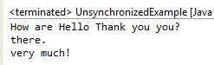

1. Now use the synchronized methods to display the desired result.

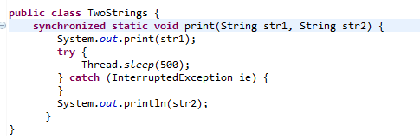

**OUTPUT**

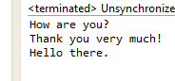

1. Now use the synchronized keyword on an object to synchronize.

**To study and implement process scheduling algorithms in Java**

**Instructions:**

In this lab, we will implement different CPU scheduling techniques.

**Lab Tasks**

1. **Shortest Job First:** The number of processes and burst time is input from the user. The program should then print total access time, burst time and wait time for every process. Also print the average wait time.

Hint: Sort the element based on their burst time

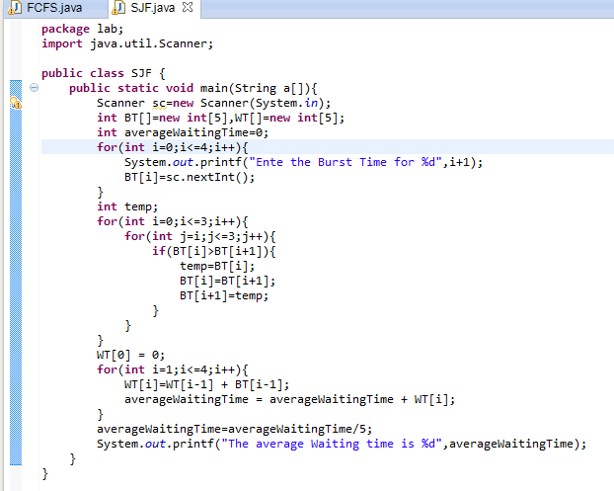

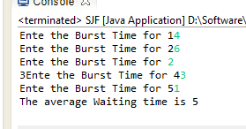

1. Simulate the First Come First Serve and Priority scheduling algorithm.

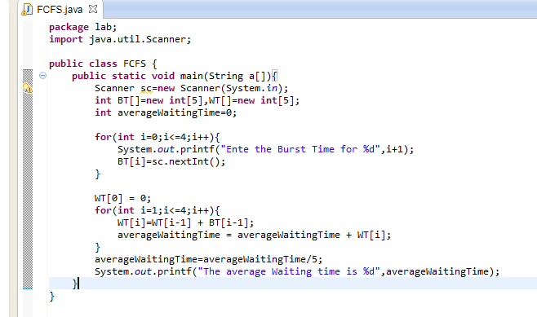

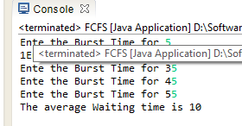

**To study and implement containers and dockers**

**Instructions:**

A container image is a lightweight, stand-alone, executable package of a piece of software that includes everything needed to run it: code, runtime, system tools, system libraries, settings.

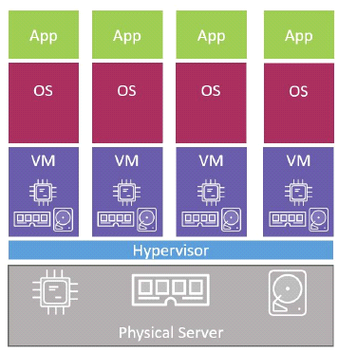 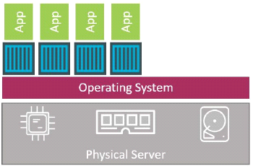

The VM Approach The container approach

Figure 10.1: The difference between container and VM approach

**Lab Tasks**

***Docker commands***

* Download and install the VMware toolbox for windows
* List the images available on your system with command “docker image ls”.
* Goto dockerhub.com and browse for repositories of alpine, python, tensorflow
* Pull the repository of alpine using docker pull alpine:latet
* Now list down the images again
* Start a container using command docker container run -it alpine:latest /bin/bash
* Run a ps command from inside of the container to list all running processes
* Press Ctrl-PQ to exit the container without terminating it
* You can see all running containers on your system using the docker container ls
* Attach to the running container again with command “docker container exec -it vigilant_borg bash” where vigilant_borg is the name of yhour cotinaer
* Press Ctl-PQ again to exit the container
* Stop the running container with command “docker container stop vigilant_borg”.
* Remove the container using command docker container rm vigilant_borg

***Building docker images***

* Clone a repository using command “git clone <https://github.com/nigelpoulton/psweb.git>”
* Change your directory using “cd psweb”
* List the contents of the Dockerfile using “cat Dockerfile”
* Build the docker image using “docker image build –t os:latest .”
* Check to make sure that the new os:latest image exists on your host
* Now run a container with the newly create image “docker container run -d --name web1 -p 8080:8080 noman:latest”
* Open a web browser and navigate to the DNS name or IP address of the host that you are running the container from and point it to port 8080
* Well done. You’ve taken an application and containerized it (built a Docker image from it).

